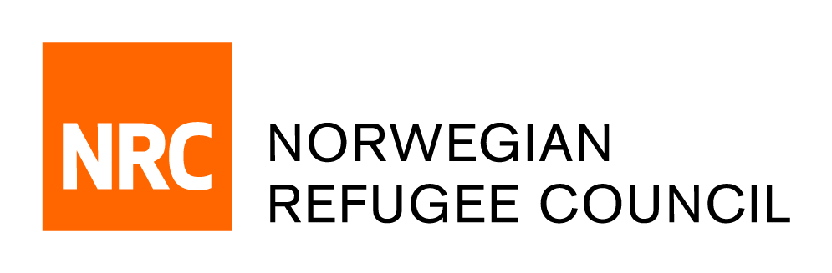

Tender Notice

Request for Proposal (RFP) for the establishment of a one-year Service Framework Agreement (FWA) for the provision of a Supermarket Digital Voucher System
in Ukraine
Tender Reference #: ITB-UA-2022-005

The Norwegian Refugee Council (NRC) has been present in Ukraine since 2014, helping more than 700,000 people with food, shelter, water, sanitation, and legal assistance. In response to the rapid change of situation in February 2022, NRC have significantly scaled up its operations. Today, NRC Ukraine is providing support to vulnerable people affected by the armed conflict and those fleeing in search of safety.

NRC Ukraine is seeking proposals from duly registered and reputable service providers for the establishment of a one-year Service Framework Agreement (FWA) for the provision of a Supermarket Digital Voucher System in Ukraine.

The Tender Dossier in English can be obtained by e-mail, free of charge, up until 17:00hrs 15th of August 2022. Please request via email ua.tenders@nrc.no siting the Tender Reference. The Tender Dossier will provide all relevant information in detail.

Deadline for submissions:
Completed Bids shall be submitted by e-mail to ua.tenders@nrc.no (only) not later than 18th August 2022 at 23h59m (Kyiv time).

