+Annex 1 Terms of Reference

Terms of Reference - Consultancy

Position: Livelihoods & Economic Recovery Consultant
Reports to: Head of Programme
Duty station: Eastern Ukraine
Travel: Multiple Field Visits
Duration: April 30th, 2022, through August 15th, 2022.

1. Background:

Seven years of active fighting have had profound consequences on the lives of more than five million people in conflict-affected Donetska and Luhanska oblasts of eastern Ukraine. Some 3.4 million conflict affected populations are in need of humanitarian assistance and protection. The vast majority of the 1.9 million people targeted for humanitarian assistance live in the two oblasts. Over 770,000 of the people targeted live in areas outside of Government-control (NGCA) while 1.14 million live in Government-controlled areas (GCA). The GCA caseload includes 189,000 people who have been internally displaced and account for 17 per cent of the people targeted in GCA. There are fewer people targeted for assistance in NGCA than GCA despite the higher severity of humanitarian needs because ongoing access constraints continue to limit operational capacity.

According to the 2021 HNO, “rising food prices, disrupted access to markets, ongoing restriction of movements of people across the “contact line”, reduction in industrial production, slow economic growth coupled with high unemployment and limited livelihood opportunities,” contribute to increased vulnerability in conflict affected areas. The COVID-19 pandemic exacerbated the crisis as it further strained access to adequate livelihoods and basic needed items. An IDP profiling conducted by NRC in Luhansk Region shows that the majority of IDPs residing in the conflict affected area are persons of productive age (18 – 59 years old) who are educated (vocational training / Bachelor's Degree / Master Degree), but are either unemployed or underemployed. Data from an economic profiling of vulnerable households in contact line communities carried out by NRC during the summer of 2021 shows that adults between 35 and 46 years old are the ones who have the lowest level of income among households living below subsistence levels. Unemployment particularly affects conflict-affected women including internally displaced (IDP), and, thus, it is critical to have a deeper understanding of the factors that drive high unemployment within this group.

In 2018 and 2019, NRC provided support to employment centres in Luhansk Oblast run by the Luhansk Agency for Employment. NRC donated equipment and rehabilitated existing infrastructure to improve service delivery on site and to introduce remote education modalities. Given the high levels of unemployment and the need to enfranchise working age vulnerable populations into broader labour markets, NRC is conducting a feasibility study to assess programming that can be delivered in partnership with the employment centres to improve access to livelihoods for conflict affected populations, particularly women between the ages of 36 and 45.

2. Objectives:

The main objectives for the consultancy include:

- To gather profile data of vulnerable unemployed female IDPs to identify skills, sources of income, coping-strategies, and socio-economic barriers that prevent them from attaining meaningful employment.
- Map programs and support services provided by employment centres and other social institutions that support women attain employment
- To assess what additional support employment centres need in order to increase service delivery (training, job matching, outreach and communications to improve visibility with job seekers) this could include tools, rehabilitation of infrastructure, etc.;
- To assess what additional vocational trainings focusing on high level skills (e.g. computer programming) could be provided in partnership with the employment centres;
- To determine what additional support key employers require to increase hiring of unemployed female IDPs aged 36 – 45 years old.
- To determine structural challenges that can be addressed through policy change.

3. Key activities:

The key activities for the consultancy will include:

Desk Review – This should be a qualitative activity where the consultant is expected to review relevant studies and other literature to frame the research. NRC and its partners have already conducted a mapping of existing studies that focus on conflict affected women including IDPs and they will be made available to the consultant. The consultant is expected to use findings to frame the tools for the in-depth interviews and focus group discussions that will be used in the technical capacity assessment of employment centres, and interviews with unemployed conflict-affected women. The consultant is expected to provide an inception report and research tools upon the conclusion of this activity.

Technical Capacity Needs Assessment Survey – This should be a qualitative activity that, in coordination with employment centres, maps the type of services provided by employment centres and other social institutions that support unemployed conflict affected women including IDPs, assess the technical capacity needs of employment centres both in terms of infrastructure, as well as equipment, and training / skills offer. The technical capacity survey developed during this activity should analyze the employment centres’ ability to conduct outreach activities focusing on access for conflict affected women, ability to scale up service delivery, and adopt new types of training provided in partnerships with external organizations. The consultant is expected to examine the current structure of the employment agencies, outline their constraints (funding, equipment, developing courses), profile and map out the types of training available, to include costs per course and duration. The consultant must explore in detail all the programmes that are designed specifically to support conflict-affected women, particularly IDPs, including requirements for entry, user demand, and potential challenges in accessing them. A mapping of existing job vacancies per sector offered by the employment centres should also be included. The findings from the technical capacity needs assessment should support the revision of survey tools for the qualitative interviews and FGDs that will be conducted with unemployed women and key employers.

Qualitative in-depth Interviews and FGDs covering unemployed vulnerable IDP women living in urban and peri-urban areas in the age range of 36 – 45 years old. In-depth interviews and FGDs will determine the average profile of vulnerable unemployed female IDPs 36 – 45 years old to identify skills, sources of income, coping-strategies, and socio-economic barriers that prevent them from attaining meaningful employment. During the FGDs and qualitative in-depth interviews, the consultant should: (1) determine women’s level of awareness about support services offered by employment centres and other social institutions; (2) determine the type of training / skills that working age women are interested in pursuing; (3) determine the geographical areas where there are larger concentrations of unemployed women; and (4) assess what additional support to access employment centres is required. Of particular interest is to identify the way in which the conflict continues to affect IDPs ability to attain meaningful employment. It is expected that the consultant will use findings from the qualitative assessment of employment centres and the desk review for this activity. At least five in-depth interviews in two locations where there is a high concentration of women should be carried out and at least one FGDs with six unemployed IDP women – 3 women from each location where there is a high concentration of unemployed women. Findings from the qualitative interviews and Focus Group Discussions should serve as basis to design tools to conduct a quantitative profiling.

Quantitative Profiling - This should be a quantitative activity covering unemployed vulnerable conflict affected women including IDPs living in urban and peri-urban areas in the age range of 36 – 45 years old. The quantitative profiling will serve to validate findings from the qualitative interviews and FGDs. Using quantitative methods, the consultant is expected to map skills, sources of income, coping-strategies, and socio-economic barriers that prevent them from attaining meaningful employment. The consultant should determine their level of awareness about support services offered by employment centres and other social institutions, assess the type of training / skills that a working age woman are interested in, and evaluate what additional support to access employment centres is required. To achieve a population distribution to validate findings, it is expected that at least 60 unemployed women are interviewed in two locations (30 each) where there is a high concentration of unemployed women.

Qualitative Interviews and FGDs covering key employers in urban settlements within the target areas. The interviews and FGDs will determine the type of skills and workers’ profile that key employers are seeking, and identify the main venues used to reach out to jobseekers. During the interviews and Focus Group Discussion, the consultant will explore, from the employers’ perspective, the barriers that prevent unemployed women within the age range of 36 – 45 years old from attaining meaningful employment (e.g. skills mismatch, policy / regulatory barriers, etc.). It is expected that findings from the desk review, qualitative mapping of employment centres, as well as interviews and FGDs with unemployed women are used. Recommendations for workforce development with a particular focus on the specific target group are required. The consultant must analyze what additional support employers need to increase hiring of unemployed females aged 36 –45. Linkages between key employers and employment centres and ways to strengthen them must be explored. It is expected that at least twelve key informant interviews in two locations where there is a high concentration of women are carried out.

4. Main deliverables:

- Deliverable 1: Inception Report, Work Plan, & Toolkit - This should include a summary of the findings from the desk review, a detailed methodology describing the overall approach, final timeline for all activities; and tools including Technical Capacity Assessment Surveys for Employment centres, in-depth interviews and FGD plan for unemployed women; and in-depth interviews and FGD plan for key employers.
- Deliverable 2: Technical Capacity Assessment Summary Findings – This should include a summary of key findings from the technical capacity assessment of employment centres. It should describe the type of programmes available for unemployed women, particularly IDPs, type of outreach and community engagement activities conducted with a focus on IDPs and other conflict affected populations. The deliverable must describe revisions made to the qualitative interview tools if any, and the updated form.
- Deliverable 3: In-depth Interviews and FGDs Summary Findings - This should include a summary of key findings from the in-depth interviews and FGDs with conflict affected unemployed women. It should describe the barriers they face for gaining meaningful employment, explore the sectors they are interested in pursuing employment, a summary of skills and needs for additional training. Of special interest is to document their perspective on their engagement and effectiveness of employment centres, awareness of the programmes available to support them, and overall recommendations on what additional support they may need to pursue employment. The deliverable must include the quantitative survey tool.
- Deliverable 4: Copy of Qualitative Interviews database - This deliverable should include a copy of the database where the 45 interviews are recorded. A basic analysis either validating, expanding, or refuting the findings of the in-depth Interviews and FGDs with unemployed conflict affected women is required.
- Deliverable 5: Key Informant Interviews Summary Findings - This should include a summary of key findings from the key informant interviews with key employers. It should the describe the type of skills and workers’ profile that key employers are seeking, and identify the main venues used to reach out to jobseekers. It should also include a description on the additional support needed to strengthen their engagement with employment centres as means to improve hiring rates of conflict affected women aged 36 to 45 years old.
- Deliverable 6: Final Report - The report should analyze in further detail all findings from the previous deliverables. All analysis and findings must be centered around the challenges faced by conflict affected unemployed women aged 36 to 45 to find meaningful employment and proposed solutions for improvement. The report must carry out the analysis from the perspective of all stakeholders and should provide programmatic recommendations on how to address them. The report should explore structural issues that can be addressed through policy change and advocacy. It is expected that two reports are provided: a summary report outlining findings which can be shared with external donors; and a comprehensive report that provides programmatic and advocacy recommendations to address challenges.

5. Locations:

Representative sample of communities within 20km of contact line in Luhansk Oblast and Northern Donetsk Oblast on Government Controlled Areas (See map).

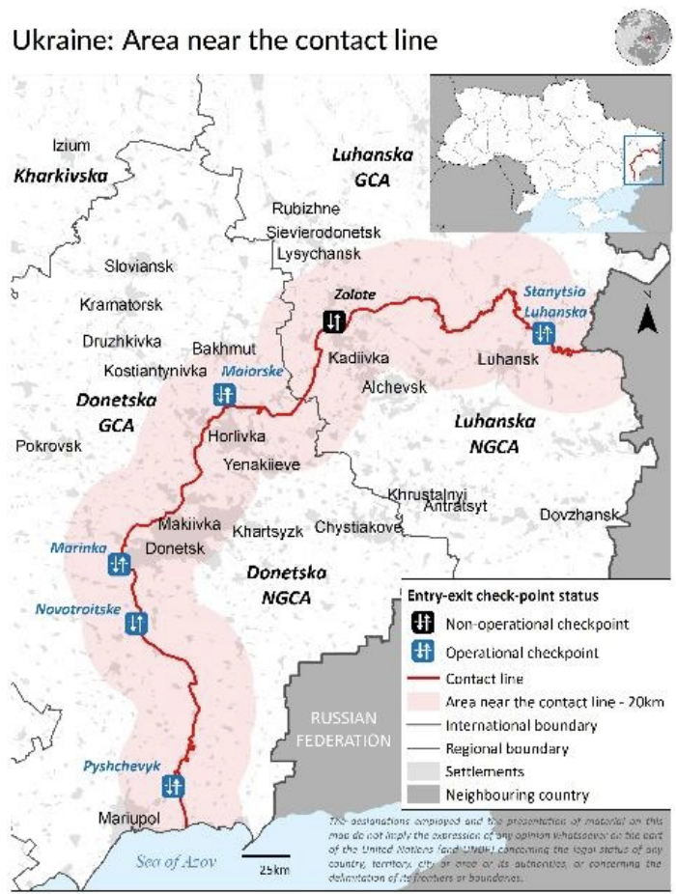
TOR Area of Intervention Map

6 Milestones

# | Expected Deliverables from the Consultant | Payment Amount | Verification of Receipt and Finalization
1 | Inception Report, Work Plan, & Toolkit | 15% | Head of Programme
2 | Technical Capacity Assessment Summary Findings | 15% | Head of Programme
3 | In-depth Interviews and FGDs Summary Findings | 15% | Head of Programme
4 | Copy of Qualitative Interviews database | 15% | Head of Programme
5 | Qualitative and FGDs Summary Findings | 15% | Head of Programme
6 | Final Report | 25% | Head of Programme

8. Payment Terms

- The payment for the evaluation service will be implemented through the NRC Head Office in Oslo in USD by bank transfer within 10 working days after submission of all required documents and deliverables by the evaluator(s) to NRC Ukraine.
- The international consultant(s) are responsible for all taxable income in their home country.

9. Required competencies:

- Relevant university degree (economics, agriculture).
- At least 10 years of proven professional experience in humanitarian-development sector
- Experience in designing large scale livelihoods/economic development programmes. Having conducted similar consultancies and reports is required.
- Excellent communication both written and oral.
- Prior experience working in capacity building.
- Prior experience working in Ukraine or the Caucasus region is highly desirable.
- Fluency in English, both spoken and written is required. Fluency in Ukrainian and Russian is highly desired, but not required.

10. Application instructions:

Applications should include the following:

- CVs;
- Cover letter addressing how the applicant meets Required Competencies;
- Expected timeline for the implementation of each activity including desk research, inception report / methodology design, travel to Ukraine and within country, interviews and FGDs with key stakeholders, and report writing.
- Must include two samples of Relevant past work;
- Please provide contact details of at least 3 references that NRC can reach out to if needed;
- Provide an itemized budget clearly indicating per diems, daily rate, flights, train tickets, and accommodation. NRC will provide road transportation while in Severodonetsk and translator if needed. It is encouraged that the consultant contacts NRC to request quotes regarding flights, trains, and accommodation so costs are reasonable and are included in the overall quotation. Budgets without itemized costs will not be accepted;
- If applying as a registered business, please provide all registration and tax documents. This can be business registration and/or VAT or company tax registration from country of origin. If no proof of registration is available, consultant (sole trader) must confirm by signing the Consultant declaration that he/she complied with self-employment regulation in his / her country of origin.

Important Notes regarding Deliverables

Reports should be submitted in Microsoft Word format, in UK English. All text should be unformatted. Graphs or other graphical devices should be editable (i.e. not pictures). All references must be cited according to convention, and detailed in a bibliography, using the Harvard system as set out in the UNESCO Style Manual. All verbatim quotations must appear in quotation marks and must not be of excessive length. All data collected under the consultancy must be submitted with the deliverables, in a widely recognized format such as Microsoft Excel.

Everything submitted to NRC must be the original work of the consultants. Any plagiarism in any form, or any other breach of intellectual property rights, will automatically disqualify the consultant from receiving any further payments under the contract by NRC, and NRC will seek to recover any payments already made.

The consultant will follow Ethical Research Involving Children guidance on the ethical participation of children. In addition, all participants in any study or other interaction will be fully informed about the nature and purpose of the interaction and their requested involvement. Informed consent must be obtained for any photographs, audio or video recordings, etc., in accordance with NRC’s policy on consent.

NRC will own the intellectual property rights to all materials submitted by the consultants under the contract. The consultants must therefore ensure that they have possession of any materials provided to NRC as a part of the deliverable. The rights to reproduce the reports will fall to NRC and its contracted agents. NRC will be free to reproduce the materials at will and to grant reproduction rights.
Annex 1 Schedule of Deliverables

Period for the Assignment

The Assignment shall be completed between April 30th, 2022, and August 15th, 2022.

Schedule of deliverables

# | Expected Deliverables from the Consultant | Schedule of deliverables
1 | Inception Report, Work Plan, & Toolkit | 15 days after contract signature
2 | Technical Capacity Assessment Summary Findings | 30 days after contract signature
3 | In-depth Interviews and FGDs Summary Findings | 45 days after contract signature
4 | Copy of Qualitative Interviews database | 60 days after contract signature
5 | Qualitative and FGDs Summary Findings | 75 days after contract signature
6 | Final Report (Draft) | 90 days after contract signature
7 | Final Report | 110 days after contract signature

Schedule of payments

Two payments will be provided. A 15% initial payment will be provided after the provision of deliverable No. 1 (payment will be provided prior to traveling). Second payment will be made upon the approval of deliverables 2 through 6. This will be signed off by the NRC’s Ukraine Head of Programme.

The Agreement, clause 4.1 Payment

The Payment for the Assignment is agreed as follows:

- Fixed price for the Assignment
 | Currency | Amount | Notes
Price for the Assignment | USD |  | excl. VAT
VAT, 0% | USD
Total price | USD |  | incl. VAT

The Agreement, clause 4.2 Invoicing

Fixed price:

Fees will be paid according to the following plan based on NRC’s satisfactorily receipt of the following deliverables:

- Deliverable 1: Inception Report, Work Plan, & Toolkit - This should include a summary of the findings from the desk review, a detailed methodology describing the overall approach, final timeline for all activities; and tools including Technical Capacity Assessment Surveys for Employment centres, in-depth interviews and FGD plan for unemployed women; and in-depth interviews and FGD plan for key employers.
- Deliverable 2: Technical Capacity Assessment Summary Findings – This should include a summary of key findings from the technical capacity assessment of employment centres. It should describe the type of programmes available for unemployed women, particularly IDPs, type of outreach and community engagement activities conducted with a focus on IDPs and other conflict affected populations. The deliverable must describe revisions made to the qualitative interview tools if any, and the updated form.
- Deliverable 3: In-depth Interviews and FGDs Summary Findings - This should include a summary of key findings from the in-depth interviews and FGDs with conflict affected unemployed women. It should describe the barriers they face for gaining meaningful employment, explore the sectors they are interested in pursuing employment, a summary of skills and needs for additional training. Of special interest is to document their perspective on their engagement and effectiveness of employment centres, awareness of the programmes available to support them, and overall recommendations on what additional support they may need to pursue employment. The deliverable must include the quantitative survey tool.
- Deliverable 4: Copy of Qualitative Interviews database - This deliverable should include a copy of the database where the 45 interviews are recorded. A basic analysis either validating, expanding, or refuting the findings of the in-depth Interviews and FGDs with unemployed conflict affected women is required.
- Deliverable 5: Key Informant Interviews Summary Findings - This should include a summary of key findings from the key informant interviews with key employers. It should the describe the type of skills and workers’ profile that key employers are seeking, and identify the main venues used to reach out to jobseekers. It should also include a description on the additional support needed to strengthen their engagement with employment centres as means to improve hiring rates of conflict affected women aged 36 to 45 years old.
- Deliverable 6: Final Report - The report should analyze in further detail all findings from the previous deliverables. All analysis and findings must be centered around the challenges faced by conflict affected unemployed women aged 36 to 45 to find meaningful employment and proposed solutions for improvement. The report must carry out the analysis from the perspective of all stakeholders and should provide programmatic recommendations on how to address them. The report should explore structural issues that can be addressed through policy change and advocacy. It is expected that two reports are provided: a summary report outlining findings which can be shared with external donors; and a comprehensive report that provides programmatic and advocacy recommendations to address challenges.

NRC invoice address: Ukraine, 93408, Severodonetsk, 10 Fedorenka str.
Reference number: UAFM2021
Name: NRC Ukraine
The invoice shall contain the bank details of the Consultancy the payment is to be processed.

OCHA, “Humanitarian Needs Overview: UKRAINE,” (https://www.humanitarianresponse.info/sites/www.humanitarianresponse.info/files/documents/files/hno_2021-eng_-_2021-02-09.pdf; Feb. 2021), 15 Apr. 2021.
NRC Ukraine. “Profiling of IDP situation in Luhansk Region, Ukraine.” (https://www.nrc.no/resources/reports/profiling-of-IDP-situation-in-luhansk-region-ukraine/#:~:text=The%20report%20%E2%80%9CProfiling%20of%20IDP,(NRC)%20in%20December%202020.&text=The%20Joint%20IDP%20Profiling%20Service,of%20methodology%20and%20relevant%20tools.; 17 Dec. 2020). 3 Sept. 2021.
NRC Ukraine. (2021). Household Economic Profiling. Kiev, Ukraine.
Source: Protection Cluster Ukraine. Map modified from “Protection Concerns Of People Living Along The Contact Line: February 2020.” (https://www.humanitarianresponse.info/sites/www.humanitarianresponse.info/files/documents/files/01_2020_protection_considerations_for_people_living_along_the_contact_line_eng.pdf; Feb. 2020), 07 Sept. 2021

