Terms of Reference

Consultancy to support development of NORCAP Expert Reporting System (ERS) Project.
Duration: October - December 2026
Responsible: Kostyantyn Bazhenov, NORCAP MEL
Location: NRC HO, Oslo or remote

Background information

Who we are: NORCAP

NORCAP works to improve aid to better protect and empower people affected by crisis and climate change. We do this by providing expertise and solutions to humanitarian, development and peacebuilding partners.
NORCAP works in two complementary ways to improve aid:
· We provide targeted expertise to strengthen our partners’ response.
· We collaborate with partners to develop solutions to unmet gaps and challenges.
NORCAP is a part of the Norwegian Refugee Council.
The NORCAP MEL unit is responsible for Monitoring, Evaluation and Learning (MEL) withing NORCAP. The MEL unit has initiated a project to design a new expert reporting system (ERS), whose goal it is to organize and streamline reporting by experts within the organisation. We have completed a market review of solutions and designed the architecture and user profiles of the ERS, and at this stage we are seeking a consultant to support the development of a minimum viable product, collect and integrate user feedback, and document processes in a user manual.

Our work
NORCAP is part of Norwegian Refugee council (NRC), and has a mission is to improve aid to protect and empower people affected by crises and climate change. With expertise in the humanitarian, development, and peacebuilding sectors, we collaborate with local, national, and international partners on finding solutions that meet the needs of people at risk.

NORCAP is the department that houses a variety of projects within humanitarian, peacebuilding and development sectors. Examples of projects are within humanitarian crisis response, inclusion and empowerment, protection, peace and democracy, climate adaptation and support to governments.

NORCAP works through partners in two different business models, system support and system change – where assignments of experts to support and work with different partners is a core activity. At any time, NORCAP has over 350 experts on assignment around the world. The experts employed by the NRC / NORCAP and deployed to more than 60 partners. Around 50 % of partners are in the UN (United Nations) system. Other partners are the Organisation for Security and Cooperation in Europe (OSCE), The African Union (AU), other multinational and regional institutions, and NGOs. National governments are also partners at the receiving end of NORCAP expertise.

Purpose of the work and intended use

Overall purpose/objective/mandate:
This assignment is supporting the second phase of the development of the internal expert reporting system (ERS) for NORCAP. In the first phase we have collected, analysed and prioritized our requirements, designed the data architecture, collected user stories and identified user profiles. This assignment will support the next phase of development where we are delivering and testing the MVP of the system.

Specifically, this assignment will require to support the MEL unit in building and testing an MVP of the Expert reporting system:
- Organizing the MS Fabric workspace for the ERS and integration of data sources from various NRC and NORCAP systems.
- Piloting solutions for surveying and data analysis modules (using kobo-derived systems), including roles, RBAC and automated dataflows.
- Creating and piloting dashboards and analytical tools for the Expert reporting system.
- Piloting internal AI powered search for data sorting and RAG within the expert reporting system datasets.
- Testing solutions with reference users, collecting and integrating feedback.
- Documenting processes for users and admins in an ERS manual.

Intended users:
- NORCAP MEL unit
- NORCAP ERS reference group, NORCAP management
- NORCAP staff (ca. 100 users)
- NORCAP experts on assignment (up to 1000 every year)

Existing Assets Provided by NORCAP

NORCAP will provide:
- Existing architecture documents and other project documentation
- Data model documentation, user profiles, etc.
- Access to Fabric workspace
- Stakeholder access
- API documentation where available

Deliverables

Key deliverables for the consultant:
- In close connection with MEL team, provide suggestions to development of the architecture of the ERS modules, semantic models, and specific variables. (The project team already has a substantial architecture documentation, including user roles, variables, and data models. We expect that consultant will help us refine and detail these documents). See also figure 1 below for illustration (it is an example of the mode, not a definite structure).
- Review and refine RBAC, data governance rules, access controls, and user permissions for the ERS workspace.
- Support the MEL team in development, documenting, and implementing data validation and quality assurance procedures for source data.
- Following established architecture, integrate data from various NRC / NORCAP sources to the Fabric workspace using API when possible. Indicative source systems to be integrated may include: Oracle HR / HCM systems, Freshworks (Freshdesk), Microsoft 365 (including SharePoint and Teams), Kobo Toolbox or equivalent survey platforms, existing NRC/NORCAP reporting systems, additional sources identified during inception phase.
- Transformation of imported data within workspace (bronze-silver-gold) according to agreed requirements, workflows, and validation procedures.
- Design and pilot a connection from the workspace data to a questionnaire / data collection software (e.g. kobo toolbox) and testing its use. See figure 1.
- Supporting a creation of dashboards and business analytics in power BI according to agreed criteria.
- Creating and prototype AI-powered search and RAG in existing reports, summarizing qualitative variables using internal copilot or other approaches (the AI search is expected to be at a prototype level).
- Support the MEL team in presenting the piloted models and prototypes to reference users, supporting the collection of feedback and integrating feedback in the ERS.
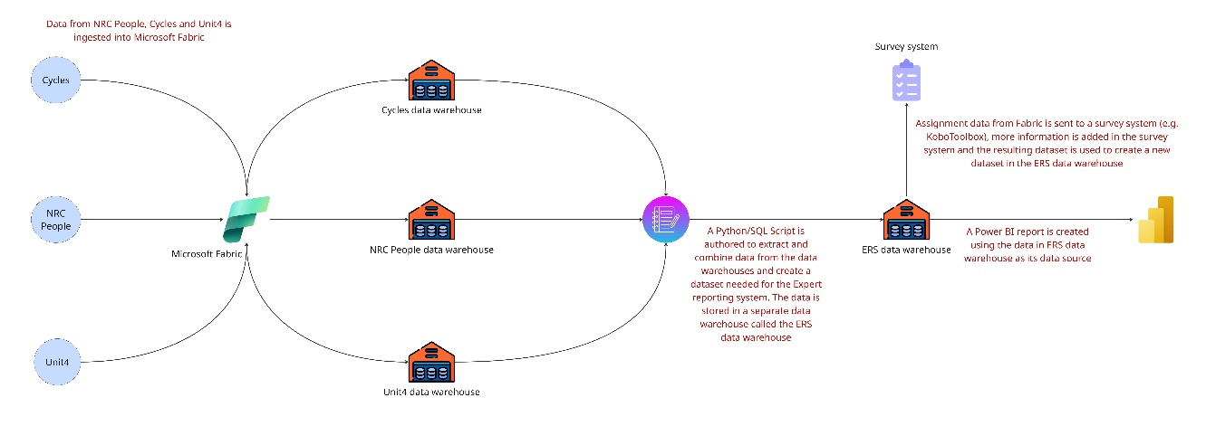
- Documenting all processes and workflows, creation of a user manual for admins and users.
Figure 1 ERS architecture (the scheme is illustrative and subject to change)

Required Qualifications and Experience:

Education
Bachelor’s or master’s degree in computer science, software engineering, data management, or similar, or over 5 years of experience in managing software development products. We allow individual consultants or consultant groups / teams to apply.

Experience
- At least 5 years of relevant professional experience:
- Demonstrated experience integrating enterprise source systems, including HR, CRM, ERP, ITSM, and survey platforms, into cloud-based data platforms. Experience with Oracle HR systems, Freshworks/Freshdesk, Microsoft 365/SharePoint, and Kobo Toolbox is considered an advantage.
- Experience with Azure Data Factory / Fabric
- Demonstrated experience designing and developing Power BI semantic models, dashboards and reports.
- Experience creating testing and documenting AI-enhanced search
- Extensive experience with reporting in international humanitarian and development sector
- Experience in data management and knowledge management approaches
- Experience in communication, facilitating workshops and collecting inputs from users and stakeholders.
- Knowledge of NRC and/or NORCAP ICT systems is a significant asset.
Languages
- Fluency in English is required.

Desirable Competencies:
- Attention to detail
- Planning and organizing - plans work, anticipates risks, and sets goals within area of responsibility.
- Professionalism - displays mastery of subject matter.
- Stakeholder orientation – works effectively well with project stakeholders.
- Project structure– listens and communicates clearly, adapting delivery to the audience.

Bids
Please send your completed bids, including the following documents, to norcap.bids@nrc.no
- Your understanding of potential risks and issues associated with the proposed scope of work and tasks. (maximum 1 page)
- Information on availability or workplan
- CVs of consultant(s)
- Daily rate or budget
- Examples (links to) similar work (or aspects of similar work)

Scoring criteria:
The bids will be reviewed on the following criteria:
- Understanding of risks related to the task
- Experience, past work and references,
- Cost,
- Availability / workplan

Deadline: October 17th, 2026
For any questions please contact: kostyantyn.bazhenov@nrc.no

Annex 2: Deadlines & Deliverables

The service is estimated to take up to 60 working days, workplan and deadlines will be agreed with the consultant.

Start date: October 2026

End date: 31 December 2026

Key deliverables for the assignment:

1. Updated architecture and data model document
2. Operational Fabric workspace with a working survey pipeline
3. Operational analytics model (template dashboards)
4. AI assistant MVP capable of semantic search and summarization of qualitative variables/fields in reports
5. User documentation – admin and user guides

Acceptance criteria:
1.Architecture and data model document, Fabric workspace and survey pipeline will be reviewed and accepted by the MEL team
2. Analytics model and dashboard and AI assistant MVP will be accepted by the reference users.

Any significant changes shall be approved by NORCAP.

Annex 3: Prices and Payment Provisions
The Payment for the Assignment, phase 1 of the project, is agreed as follows:

Schedule of payments
- 1st payment after the completion of an MVP prototype – 30%
- 2nd payment after the completion of analytics module and a first round of testing and feedback - 30%
- 3rd payment after the testing, feedback, and improvement of the MVP prototype and completion of the documentation draft – 30%
- 4th payment after addressing all the relevant requests from the MEL team – 10%
- In case the consultant needs to acquire subscriptions or cover software costs to access solutions for testing and development, NORCAP should be consulted beforehand and agree to the purchase for each case. These licenses or subscriptions should be transferred to NORCAP and the costs invoiced by the consultant as part of consultancy expenses.

Invoicing: The invoice must be specified and documented in a way that NRC can easily check that the agreed fee has been complied with. If expenses are to be reimbursed, they must be preapproved by NRC and original receipts/invoices must be enclosed unless otherwise agreed in writing.

