Terms of Reference (ToR)

Consultancy for the Upgrade and Redesign of NIF Official Website

1. Background
The Nigeria INGO Forum (NIF) is an alliance of international NGOs that provides humanitarian and development assistance in Nigeria. NIF facilitates collective action among its members to deliver principled and effective assistance that saves lives and improves the well-being of vulnerable populations. NIF currently maintains a website (https://ingoforum.ng/) that provides an overview of its activities; however, the site requires significant improvements in design, structure, functionality, and content presentation to meet modern digital communication standards. To achieve this, NIF seeks to recruit a qualified consultant or consulting firm to upgrade and redesign the existing website.
2. Objective of the Assignment
The main objective of this assignment is to update and revamp the existing website.
- Redesign and restructure the website to improve usability, navigation, and overall user experience across all devices and internet environments.
- Add new functionalities
    - Membership Application and Tracking System
    - Secure Member Login Portal
    - Member only Information and Resource Repository
    - Membership Fee Status Monitoring
    - Member Job Posting Platform
    - Member Project Information Management
    - Member Contact Information Management
3. Reports To
IM Technical Advisor INGO Forum
4. Deliverables
The consultant will be responsible for the following deliverables:
- Website Upgrade and Redesign – Enhance the existing website's design, functionality, user experience, and performance.
- Website Deployment – Successfully deploy the upgraded website to the production environment and ensure it is fully operational.
- Updated Source Code – Provide the complete, updated source code, including all associated files, documentation, and configurations required for future maintenance and development.
5. Duration of the Assignment
This assignment is supposed to be completed within four (4) weeks from the date of contract signing.
6. Qualifications
- Bachelor's or master's degree in a relevant field (e.g., Computer Science, Software Engineering, Data Science, or related discipline).
- Minimum (3) three relevant projects within the last 5 years in web development
7. Technical Requirements
- Proven hands-on experience designing, developing, and maintaining production grade web applications using Go (Golang) for backend services and Angular / TypeScript for the user interface.
- Experience using Git and GitHub to manage source code, collaborate with cross-functional teams, and support automated deployment pipelines.
- Experience deploying and orchestrating docker containerized applications using CapRover or similar lightweight PaaS engines.
8. Proposal Submission Requirements
Interested Individual consultants or consulting firms are expected to submit the following:
- A technical proposal outlining the understanding of the assignment, the methodology, and the approach, A proposed work plan and timeline, experiences and team compositions etc.
- A financial proposal outlining the total cost of the assignment
- A portfolio of similar/relevant assignments/experiences and website links
- Consultant Profile/CV (max. 3 pages; for firms, profiles of proposed experts).
- Company profile
- Attach your CAC (Status must be active), TCC -2024 or 2025
9. Evaluation Criteria
Proposals will be evaluated based on the following criteria
a). Demonstrated understanding of the assignment, relevant experience, and the quality of the proposal.
b) Clarity, feasibility, and effectiveness of the proposed methodology, work plan, and timeline for delivering the assignment.
c). Financial offer - overall value for money of the proposed budget in relation to the scope of work and deliverables.

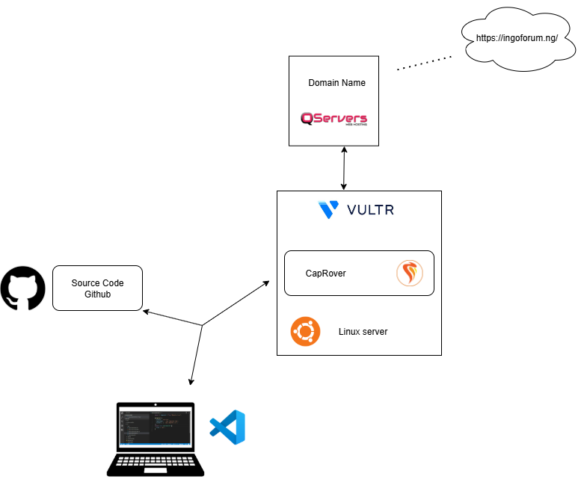
Architecture

