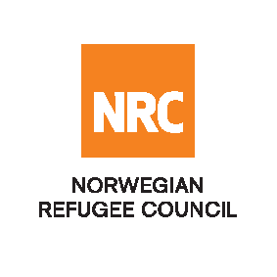

**INVITATION TO TENDER**

The Norwegian Refugee Council (NRC) is a non-governmental, humanitarian organization with 75 years of experience in helping to create a safer and more dignified life for refugees and internally displaced people. NRC advocates for the rights and provides assistance, protection and durable solutions to refugees and internally displaced persons worldwide.

NRC has been operating in Nigeria since late 2015 providing assistance with Emergency shelter, Livelihoods and Food Security, Water, Sanitation and Hygiene sectors, Information Counseling and Legal Assistance, Camp Management and Education.

Norwegian Refugee Council (NRC) invites bids from competent consultancy service providers for the following:

|  |  |  |
| --- | --- | --- |
| **Internal Reference** | **Tender Category** | **Closing date** |
| 28/NRC-NAT/NG/2025 | Invitation to Tender: Consultancy for End of Project Evaluation in Plateau State | 6th August 2025 |

All interested bidders should visit the NRC website; <https://www.nrc.no/procurement/>; <https://procurement.ngojobsite.com/>; <https://etenders.com.ng/> and download the package in order to apply for this tender.

All applications/proposals are accepted in English, must duly be completed and submitted via [ng.tenders@nrc.no](mailto:ng.tenders@nrc.no)

Late bids shall be rejected, and no liability will be accepted for loss, late delivery or non-delivery, whatsoever.

***NRC reserves the right to select/reject any bids, in part or full, as it may deem necessary. No liability or claim in that respect would be admissible or entertained whatsoever.***

In case you have any questions regarding this consultancy, please direct them to: [ng.tender@nrc.no](mailto:ng.tender@nrc.no)

Please note one can submit questions until 29th July 2025 at midnight (Nigeria time). All questions will be gathered, and the responses posted at the NRC website <https://www.nrc.no/procurement/> by 31st July 2025.

The application should be titled:

**“28/NRC-NAT/NG/2025” – “Consultancy for End of Project Evaluation in Plateau State”** in the e-mail subject.

**Submission deadline is 6th August 2025 at mid-night (Nigeria Time).** Failure to meet the closing date will result in the bid being rejected. Only short-listed/successful candidates will be contacted.