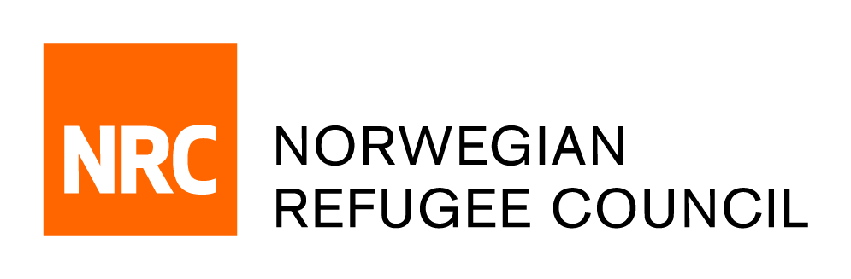

CALL FOR CONSULTANCY
RFQ/ SN/02 FEB / 2022/ 8100108

We ask you not to change the request form, not to add or delete sections of the request for quotation, but simply fill in the required fields.
ATTENTION: Legal entities and/or individuals, whose relations might affect the conditions or economic results of their activities or the activities of individuals they represent, are NOT ALLOWED to participate in the tender at the same time.
The submission of all or part of the quotation in a freely editable format (Word, TXT, etc.) is NOT ALLOWED. Submission of the quotation shall be in the established format (scans of all pages of the quotation, either in separate .jpg files, or in a separate/single .pdf file, a PDF document with a signature/seal).

From: | NRC Dakar |  | Logistics Team
Email | sn.procurement@nrc.no
Date of RFQ |  | 07.02.2022
No. of pages including this page: 3
Subject: | Consultancy services
Reference number |  |  | RFQ/ SN/02 FEB / 2022/ 8100108
Manner of Submission:
Please submit your quotation in accordance with the requirements detailed below by :
By email to: |  |  |  |  |  | sn.procurement@nrc.no
Deadline for submission of quotations is |  |  | 21.02.2022 | 11:00 AM | Firms/ consultants who do not submit their quotation by this deadline will not be considered

Requirements:
The Norwegian Refugee Council (NRC) invites qualified firms/ Consultants to make a firm offer for the following services:

# | Scope of service | Specification | Qty | Unit | Price per unit, USD | Total cost, USD
1 | Evaluation on Durable Solutions in Nigeria:  Building Tools for Better Advocacy and Programming | Please, see Terms of Reference / | 1 | Service
Total
Price in quotations must be in USD, specification must comply with requested parameters (TOR). Price must include taxes (including VAT, if applicable). Proposal with different data will not be taken into account.
NRC Evaluation Criteria and Weighting:
a. Proposal/Bid Quality (Demonstrated understanding of the scope of the ToR, via a clear proposed methodology for conducting evaluation) – 30%;
b. Capacity (Demonstrated reliability in delivery of quality services, as illustrated by relevant previous experience and quality of writing samples)– 25%;
c. Relevance (Academic qualifications, relevant evaluation experience, relevant experience in Nigeria )– 20%;
d. Financial proposal (service fee) – 25%.

Your quotation should clearly indicate the following:
· The time required to perform the service from the time of order confirmation (working days)
· Proposed budget detailing consultancy fees and all budgets and final quotations should be made in USD.
· NRC will not cover travel expenses, insurances and other expense allowances.
Yes or No
· Payment terms (100% postpayment within 15 working days for the delivered batch after receiving of original documents which are required for payment):
Do you accept the condition ? Yes or No
· Validity of the offer (days) - not less than 30 days:
Please, attach to proposal and specify the list of the enclosed files:
- cover letter with a brief presentation of your consultancy experience and explaining your suitability for the work, including previous pertinent projects and how they are linked to this project;
- An in-depth methodology on how you will undertake work and achieve outputs set out in the terms of reference;
- The resume of key staffs must be annexed to the application documents in French or English.
- Proposed timeline and expected delivery for each deliverable;
- Team composition and quality assurance approach.
- Documentation of the consultant’s business registration. However, if this is not possible, the consultant (sole trader) should confirm by signing the Consultant declaration (Mandatory) that he/she complied with self-employment regulation in his/her country of origin;
VAT payer (yes/no). If yes – please attach the copy of confirming document, signed and stamped
Conditions of quotation:
All suppliers doing business with NRC should maintain high standards on ethical issues, respect and apply basic human and social rights, ensure non-exploitation of child labor, and give fair working conditions to their staff. NRC reserves the right to reject quotations provided by suppliers not meeting these standards.
Vendors doing business with NRC will be screened on anti-corruption due diligence before NRC confirms an order or contract.
Your quotation may be disqualified for the following reasons:

1. If the quotation contains arithmetic errors.
2. If the quotation does not match the requested format (submitted in own format of the supplier) or structure of NRC form is altered.
3. If the quotation is provided after the set deadline.
4. If the quotation is not stamped and/or not signed.
5. If the quotation is submitted in freely editable format.
6. If the supplier, who provided the quotation and won, will not be able to deliver (perform work, provide services) from the organization, which submitted the quotation
7. Legal entity and/or private person, the relationship between them may affect the conditions or economic results of their activities or the activities of persons they represent do not have to participate in the tender at the same time.

All questions, please send in writing to the e-mail sn.procurement @nrc.no, email subject: RFQ/ SN/02 FEB / 2022/ 8100108

Supplier Information
Company name |  | Stamp  Sign
Address
Name and position of the representative of the company who signed the document, proof of authority shall be attached
Contact person (if different from the signatory)
Contact telephone number
Email /
NRC reserves the right to accept or reject the whole or part of your quotation based on the information provided. Incomplete quotations, which do not comply with our conditions, will not be considered.

