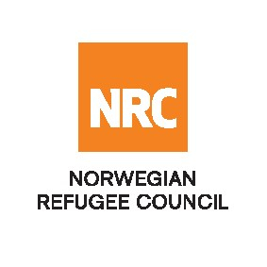
CALL FOR CONSULTANCY SERVICES

The Norwegian Refugee Council (NRC) invites qualified firms/ Consultants to tender for the following consultancy service:

SCOPE OF SERVICE
The Contracts eligible for bidding are
Service Description | Reference contract :
Consultancy for Evaluation of ISoLT – Supporting Social Inclusion and Local Governance in the areas most impacted by the Lake Chad Crisis | 60/NRC-NOT/NG/2021

Tender documents
Download the full ITB with detailed instructions

For additional information, please send your inquiries to: sn.procurement@nrc.no before the closing date

Submission process
All interested and eligible firms/ consultants are requested to submit their bids to sn.procurement@nrc.no

Deadline: All bids must be submitted no later than 30th November, 2021 at 5: 00 pm (Dakar time) by email to sn.procurement@nrc.no
Late bids will be automatically rejected.

