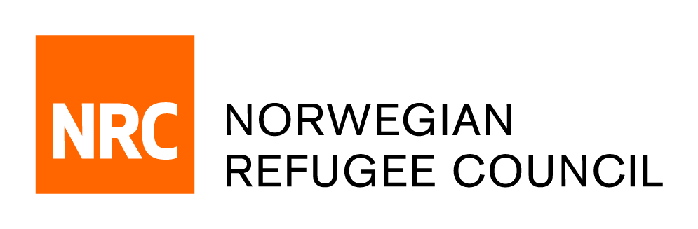

Tender Notice

Provision of “Yemen Economics Technical Experts”
REF: ITB.MERO.2021.01.ACAPS

The Norwegian Refugee Council (NRC) is a non-governmental, humanitarian organization with 60 years of experience in helping to create a safer and more dignified life for refugees and internally displaced people.

- Tender Purpose:
NRC Middle East Regional Office in Amman, Jordan, is soliciting bids for Yemen Economics Technical Experts consultancy.

- Deadline for tender:
The complete tender dossier in English language can be obtained by e-mail, free of charge, up until the day before the closing date 16th of June 2021. The tender dossier can be requested by emailing mero.logistics@nrc.no.

Quoting reference number ITB.MERO.2021.01.ACAPS and stating the name of the company requesting the documents.

Note that questions about this invitation to bid can be put forward by email to mero.logistics@nrc.no and that a Q&A feedback will be shared with all bidders with anonymization.

