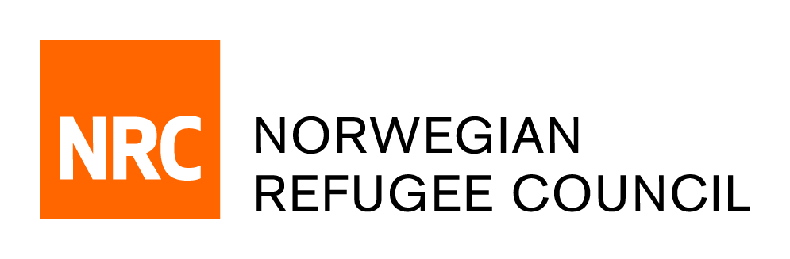

Tender Notice

Provision of “Staff Care and Employee Resilience Services”
REF: ITB.MERO.2020.0831

The Norwegian Refugee Council (NRC) is a non-governmental, humanitarian organization with 60 years of experience in helping to create a safer and more dignified life for refugees and internally displaced people.

In recognition of the challenging environments in which we operate, NRC MERO wishes to strengthen its staff care resources to ensure we can proactively build resilience amongst our staff and build a more holistic and culturally appropriate approach to staff care support. We are therefore seeking to partner with a service provider who can meet a range of needs within the region primarily to provide services for individual and group counselling and coaching, management support in duty of care responsibilities and the provision of training and support to help NRC proactively address employee wellbeing.

NRC Middle East Regional Office in Amman, Jordan is soliciting bids from reputable suppliers to provide Staff Care and Employee Resilience Services.

The complete tender dossier in English language can be obtained by e-mail, free of charge, up until the day before the closing date 7th of October 2020. The tender dossier can be requested by emailing mero.logistics@nrc.no.

quoting reference number ITB.MERO.2020.0831 and stating the name of the company requesting the documents.

Note that questions about this invitation to bid can be put forward by email to mero.logistics@nrc.no and that a Q&A feedback will be shared with all bidders with anonymization.

