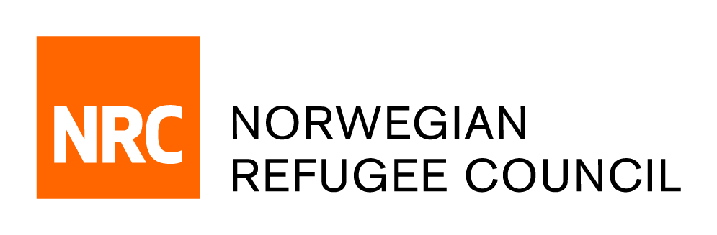

Request for Quotation
Consultancy: Youth Programme Evaluation - Camps
RFQ/JDFY/2020/132

NRC – Jordan office is seeking a consultant(s) with experience to conduct an evaluation for Youth Camps.
NRC- Jordan provides services in the following sectors: Shelter, Education, Youth, Basic Needs, Livelihoods and Information, Counselling, and Legal Assistance (ICLA).
Jordan is home to over 1.4m youth and 70% of the population is under 30 years old. This ‘youth bulge’ creates challenges in provision of youth services and meeting socio-economic needs, but also presents a potential ‘youth dividend’ to support Jordan’s development

In order to respond to this situation, the NRC Youth Programme in Jordan supports young people gain skills and build relationships to pursue a variety of pathways including social engagement and volunteering, livelihoods, and further study.

The evaluation aims to learn more about the impact of the current NRC Youth programme on young people as well as the effectiveness and relevance of activities given the contextual changes in the camps. This learning will contribute to shaping the upcoming multi-year Core Competency strategy that the team will design in 2021.

Full details of the consultancy can be found in the Terms of Reference enclosed in below link

Deadline for bid submission:
The deadline for submission of bids is on the 25th of January 2021. Bidders who do not submit their bids by this deadline will not be considered.

Complete Request for Quotation can be obtained by following this link, free of charge from the 6th of January 2021 until the closing date on the 25th of January 2021.

for any questions or technical issues please contact us at jordan.procurement@nrc.no

