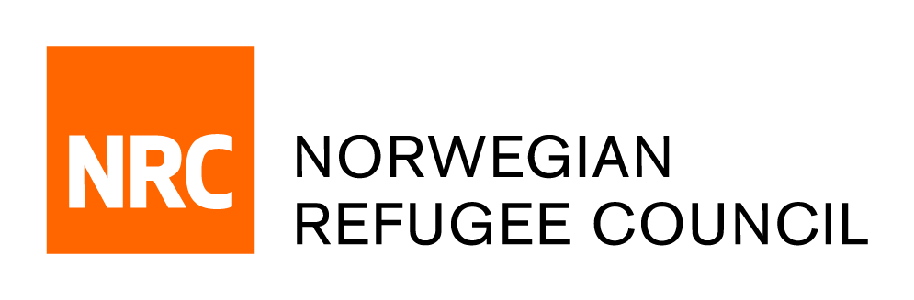

Tender Notice

Tender for the Establishment of a Framework Agreement for the provision of Minivan And Bus Rental
ITB/JDFY/2021/005

NRC – Jordan office is soliciting bids from reputable companies that are duly registered/licensed for the establishment of two Years Framework agreement for the provision of Minivan and Bus Rental Tender Ref# (ITB/JDFY/2021/005)

Deadline for tender:
The deadline for submission of tenders is 14.00 on the 08th of August 2021. Companies who do not submit their bid by hand on this deadline will not be considered.

Complete tender documents can be obtained, free of charge from the 13th of July 2021 until the deadline on the 08th of August 2021, by accessing the following link

https://forms.office.com/Pages/ResponsePage.aspx?id=tNGGP2ssGkuyrm9elQvKHkhcXp73o5dJmw8xbISj7fhUMk9BU1pJRjM5TkpaRVFRN0JJWDMxRE80Ni4u

If you have any technical issues, please contract us on jo.contact@nrc.no, considering that NRC will not share the bids via email as all bidders must register their interest using the above mentioned link.

