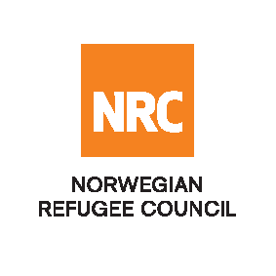

Tender Notice
Consultancy Services for Value Chain Assessment in Iraq (Ninawa and Kirkuk Governorates)
IRAQ-ITB-2020-013

NRC is an international non-governmental, humanitarian organization with 60 years of experience in helping to create a safer and more dignified life for refugees and internally displaced people. NRC advocates for the rights of displacement-affected populations and works in the following six main core competencies: Shelter; Education; Livelihoods and Food Security; Information, Counselling and Legal Assistance (ICLA); and Water, Sanitation and Hygiene (WASH).

NRC has been present in Iraq since 2010, and currently has offices located in Ramadi, Basra, Erbil, Dohuk, Hamam Al Alil, Mosul, Sinjar and Kirkuk. NRC has scaled up its response across Iraq to meet the large-scale crisis facing the country, reaching Iraqis with emergency assistance and economic recovery programs. Our goal is to always be prepared to work in new settings, so we are establishing more local partnerships in Iraq.

NRC is implementing three (3) years Agricultural livelihoods project (AMAL- Activating Market-based Agricultural Livelihoods) in Ninawa and Kirkuk governorates targeting three districts (Sinjar, Ba’aj and Hawija) with funding support from KfW (German Development Bank). Primary program objective is to promote the resilience of conflict-affected rural Iraqi communities through the restoration of agricultural production, markets and associated livelihoods through market development and value chain approaches. This project specifically focuses on a) increasing agricultural productive capacity of farmers within the targeted areas, b) revitalization of markets within the agricultural value chain provides for increased employment opportunities in the targeted areas and c) targeted communities enhance their resilience to future shocks.

The Norwegian Refugee Council (NRC) Office in Iraq invites interested consultants to conduct a detailed Value Chain Assessment on agricultural value chains in Ninawa and Kirkuk governorate to identify strengths, weaknesses and opportunities for programming interventions.

Deadline for the tender & Method of Submission:
The deadline for submission of tenders is 15:00 (Iraq time) on the 12th April 2020. Bidders should submit their offers in a sealed envelope and place them in a tender box in the NRC Office in Erbil, Kirkuk, Mosul or send them by courier service to the respective NRC Offices. Alternatively, electronic submission will be accepted. Details of the submission method can be found in the tender package. Companies who do not submit their quotation by the deadline will not be considered.

To receive the tender package:
The consultant has to fill the form attached to this link (Click to Register), then NRC will send the tender package to the registered consultants. For more information please send an email to iq.procurement@nrc.no highlighting the tender reference number in the subject of the email.

NRC reserves the right to select/reject any bids, in part or full, as it may deem necessary without providing feedback on this regard. No liability or claim in that respect would be admissible or entertained whatsoever.

