Norwegian Refugee Council (NRC)
Invitation to Bid Services

SECTION 1
Cover Letter
Oslo, 2 September 2026

SUBJECT: INVITATION TO TENDER FOR THE ESTABLISHMENT OF A FRAMEWORK AGREEMENT FOR CREATIVE AND EDITORIAL SERVICES

Dear Mr/Ms

Following your enquiry regarding the publication of the above-mentioned invitation to tender, please find enclosed the following documents, which constitute the tender dossier.

Any request for clarification must be received by NRC in writing at least 3 working days before the deadline for submission of tenders. NRC will reply to bidders' questions at least 2 working days before the deadline for submission of tenders.

Costs incurred by the bidder in preparing and submitting the tender proposals will not be reimbursed.

We look forward to receiving your tender at the address specified in the Instructions to Bidders by 18 September 2026, at 17:00 Oslo Local Time, as stated in the procurement notice.

If you decide not to submit a tender, we would be grateful if you could inform us in writing, stating the reasons for your decision.

Yours sincerely,

NRC Procurement Department

On behalf of the Bid Analysis Committee

This ITB document contains the following:
- Section 1: This cover letter
- Section 2: Bid data sheet
- Section 3: NRC invitation to bid general terms & conditions
- Section 4: Technical description of the Bid
- Section 5: Bidding form
- Section 6: Service provision schedule
- Section 7: Company profile and previous experience
- Section 8: Service description and pricing proposal
- Section 9: Ethical standards declaration
- Annex 1: Service provision and pricing proposal

SECTION 2
Bid Data Sheet
- Background Data
Contract Name: Invitation to Tender for the Establishment of a Framework Agreement for Creative and Editorial Services | Contract Number: N/A

This bid is issued by the Norwegian Refugee Council (Head Office in Oslo). Any requests for clarification can be addressed to the following address: exrel.tenders@nrc.no or Prinsens gate 2, 0152 Oslo, Norway.

- Scope of Service

Please refer to the service specifications in section 4.

- Schedule & Deadline for Submission

The deadline for submission of bids is 18 September 2026, at 17:00 Oslo Local Time. Late bids will not be accepted.

 | DATE | TIME*
Invitation to Bid release | 04/09/2026 | 17:00
Deadline for request for any clarifications from NRC | 15/09/2026 | 17:00
Last date on which clarifications are issued by NRC | 16/09/2026 | 17:00
Deadline for submission of bids (receiving date, not sending date) | 18/09/2026 | 17:00
Tender opening session by NRC | 21/09/2026 | 12:00
Notification of award to the successful tenderer | 25/09/2026 | 12:00
Signature of the contract | 02/10/2026 | 12:00
* All times are in the local time of Oslo, Norway

Please note all dates are provisional dates and NRC reserves the right to modify this schedule.

- Manner of Submission:

Please submit your bids in accordance with the requirements detailed below:

Complete sealed bid documents shall be either hand delivered at NRC Head Office at Prinsens gate 2, 0152 Oslo, Norway no later than 17:00 Oslo Local Time, on the due date indicated above or by email to the following address: exrel.tenders@nrc.no with the subject line: “Invitation to Tender for Creative and Editorial Services”. Supporting documents should be submitted through a zipped folder or online link.

Any questions or clarifications are addressed via exrel.tenders@nrc.no.
- Assessment Criteria

Award of the contract(s) will be based on the following:

Step 1: Administrative compliance check

Bidders must provide evidence of the following for their bid to be considered compliant:
- Sections 3-9 and Annex 1 completed and signed.
- Bidder has included a copy of their valid business licence.
- Bidder has included a copy of their tax registration

Step 2: Technical Evaluation

A Technical Evaluation of all bids received will be conducted for bidders that pass Step 1 – Administrative Compliance Check. Criteria that will be used to evaluate and score the bids are outlined in Section 3, Clause 26.

Step 3: Financial Evaluation

Price in comparison to NRC established expectation and to other bidders of comparable technical quality.

- Bidder’s checklist (to be adjusted as per conditions of tender)
Description | To be filled by bidder |  | To be filled by NRC bid committee
 | Included? |  | Present & complete? |  | Comments
Step/ document to be submitted with tender | Yes | No | Yes | No
Section 2- Paragraph 6. Bidder’s checklist - Compulsory
Section 3 – General Terms & Conditions – signed- Compulsory
Section 4 –Service Provision – completed, signed – Compulsory
Section 5 – Bidding Form – completed, signed – Compulsory
Section 6 – Service Provision Schedule – signed – Compulsory
Section 7 – Company profile & experience – completed, signed– Compulsory
Section 8 – Service provision description and pricing proposal – completed, signed – Compulsory
Section 9 – Ethical Standards Declaration – signed – Compulsory
Annex 1: Service Provision and Pricing Proposal – Compulsory
Supporting documents
Copy of company registration – Compulsory
Copy of tax registration – Compulsory
References and proof of experience - Compulsory

To be filled in by NRC bid committee only | Eligible | Ineligible
Outcome of administrative eligibility check.

SECTION 3
NRC Invitation to Bid - General Terms & Conditions

- Scope of Bid
  - The bid is based on the scope of the assignment as determined in the Bid Data Sheet (Section 2). The instruction to bidders should be read in conjunction with the Bid Data Sheet.
  - The successful Bidder will be expected to complete the assignment by the Intended Completion Date specified in the contract to be signed.

- Corrupt Practices
  - Norwegian Refugee Council requires Employees, Bidders and Contractors, to observe standards of ethics during procurement and the execution of contracts. In pursuit of this, Norwegian refugee Council defines, for the purposes of this provision, the terms set forth below as follows:
  - “Corrupt practice” includes the offering, giving, receiving, or soliciting of anything of value to influence the action of a public official in the procurement process or in contract execution;
  - “Fraudulent practice” includes a misrepresentation of facts in order to influence a procurement process or the execution of a contract to the detriment of the Norwegian Refugee Council, and includes collusive practices among Bidders prior to or after bid submission designed to establish bid prices at artificial, non-competitive levels and to deprive the Norwegian Refugee Council of the benefits of free and open competition;
  - In any case where fraud or corruption is identified, NRC will:
- reject any bids where the Bidder has engaged in corrupt or fraudulent practices in competing for the Contract;
- remove bidding contractors who engage in fraudulent or corrupt practices, from our prequalified list
- liaise with District Officials to report if fraudulent or corrupt practices are identified
- terminate works
  - Any communications between a Bidder and the Norwegian Refugee Council related to matters of alleged fraud or corruption must be made in writing via inbox@nrc.caseiq.app or this online form honestly and in good faith

- Data Protection and Security
  - NRC expects contractors who process personal data to comply with the General Data Protection Regulation (EU GDPR) and any relevant national legislation. Suppliers processing personal data on an NRC contract will be required to sign a data processing / sharing agreement as a part of the contract. Refusal to sign such an agreement constitutes refusal of the contract terms and forfeiture of the contract on the part of the supplier.

- Eligible Bidders
  - A Bidder shall meet the following criteria to be eligible to participate in NRC procurement of Services:
- the bidder, at the time of bid, is not:
    - insolvent;
    - in receivership;
    - bankrupt; or
    - being wound up
- the bidder’s business activities have not been suspended;
- the bidder is not the subject of legal proceedings for any of the circumstances in (b); and
- The bidder has fulfilled his or her obligations to pay taxes and social security contributions. In a case where VAT is included in a bid, a copy of the VAT certificate must accompany the bid.
- A Bidder, and all parties constituting the Bidder, including sub-contractors, shall not have a conflict of interest. All Bidders found to have an undisclosed conflict of interest shall be disqualified. A Bidder may be considered to have a conflict of interest with one or more parties in this bidding process if they have a relationship with each other, directly or through common third parties that puts them in a position to have access to information about or influence on the bid of another Bidder, or influence the decisions of the Norwegian Refugee Council regarding this bidding process.
  - A Bidder whose circumstances in relation to eligibility change during a procurement process or during the execution of a contract shall immediately inform the Norwegian Refugee Council.
  - NRC reserves the right to refuse a bid at any time if the bidder or any party constituting the Bidder, including one of its sub-contractors violates any of the ethical standards provided in section 9 of this Invitation to Bid.

- Joint Ventures, Consortia and Associations
Bids submitted by a joint venture, consortium, or association of two or more firms as partners will not be accepted.

- One Bid Per Bidder Per Work
Each Bidder shall submit only one Bid per contract. A Bidder who submits or participates in more than one bid per contract will cause all the bids with the Bidder’s participation to be rejected.

- Cost of Bidding
The Bidder shall bear all costs associated with the preparation and submission of his Bid, and the Norwegian Refugee Council shall not be responsible or liable for those costs, regardless of the conduct or outcome of the bidding process.

- Inspection
NRC is obliged to ensure that its procurement decisions are clearly justified and documented and keeping within the Donors mandatory principles. In that regard, full and on-the-spot access must be granted to representatives of NRC, the Donor or any organisation or person mandated by it, to premises belonging to NRC or its contractors. The right to access shall include all documents and information necessary to assess, or audit the implementation of the contract.

- Obtaining and Completing Bidding Documents
  - Bidders who did not obtain the Bidding Document directly from the Norwegian Refugee Council will be rejected during evaluation. Where a Bidding Document is obtained from the Norwegian Refugee Council on a Bidder’s behalf, the Bidder’s name must be registered with the Norwegian Refugee Council at the time of issue.
  - The Bidder is expected to examine all instructions, forms, terms, and specifications in the Bidding Document. Failure to furnish all information or documentation required by the Bidding Document may result in the rejection of the bid.

- Clarification of Bidding Document
A prospective Bidder requiring any clarification of the Bidding Document shall contact the Norwegian Refugee Council in writing. The Norwegian Refugee Council will respond in writing to any request for clarification before the deadline for clarification of bids. The Norwegian Refugee Council shall forward copies of its response to all Bidders who have acquired the Bidding Document, including a description of the inquiry but without identifying its source.

- Amendment of Bidding Document
  - At any time prior and until 48 hours prior to the deadline for submission of bids, the Norwegian Refugee Council may amend or cancel the Bidding Document by informing the bidders in writing.
  - To give prospective Bidders reasonable time in which to take an amendment or cancellation into account in preparing their bids, the Norwegian Refugee Council can, at his discretion, extend the deadline for the submission of bids.

- Language of Bid
  - The bid, as well as all correspondence and documents relating to the bid shall be written in English.
  - Supporting documents and printed literature that are part of the bid may be in another language provided they are accompanied by an accurate translation of the relevant passages in English, in which case, for purposes of interpretation of the Bid, such translation shall govern.
  - Copies of official documents such as business registration, tax documents, bank guaranty can be provided in their issuance language.

- Documents Comprising the Bid
  - The bid submitted by the Bidder shall comprise all the mandatory documents listed in Section 2 Paragraph 06. Bidders’ checklist.
  - All forms must be completed without any alterations to the format, and no substitutes shall be accepted. All blank spaces shall be filled with the information requested.

- Bid Price for Service Contract
  - Bid prices are for complete contracts. Contracts cannot be subdivided into pieces unless is divided into lots. Where a bid is submitted per contract / lot, all relevant services must be offered.
  - Items for which no rate or price is entered by the Bidder will be as not quoted.
  - Unless otherwise specified in Section 2 - the Bid Data Sheet, all duties, taxes and other levies payable by the contractor under the contract, shall be included in the total bid price submitted by the bidder.
  - For bidder subject to VAT, VAT should be mentioned in the offers
  - The prices submitted by any Bidder shall be checked for arithmetical errors and for what might be considered unreasonable rates during the evaluation. Where errors are identified one or more of the following steps may be taken:
- If any rates are considered to be unrealistic or unreasonable they may be altered by mutual agreement, provided that no alteration shall be made in the amount of the Bid.
- If any arithmetical errors are detected in an otherwise acceptable bid, and the Bidder, on being so notified, is prepared to confirm his bid and if the Bidder is subsequently awarded the contract, then the Bid shall be altered to reflect the difference.
- The Bidder is reminded that it is entirely his responsibility to ensure the accuracy of his bid. No alteration will be made to the bid after its submission on the grounds of any arithmetical errors subsequently discovered except as provided above.

- Currencies of Bid and Payment
All prices shall be quoted by the Bidder in EUR. The currency of all payments will be made according to the nationality of the awarded supplier and will be agreed prior to contract award.

- Bid Validity
  - Bids shall remain valid for the full duration of the Framework Agreement, namely for a period of 2 years after the date of the contract award as prescribed by Norwegian Refugee Council. A bid valid for a shorter period shall be rejected as non-compliant.
  - In exceptional circumstances, prior to the expiration of the bid validity period, the Norwegian Refugee Council may request Bidders in writing to extend the period of validity of their bids. A Bidder must confirm in writing his acceptance of the extension. In case of extension, modification of the bid is not permitted.

- Alternative Bids
Bidders shall submit offers that comply with the requirements of the bidding documents, including the basic technical design as indicated in the drawings and specifications. Alternative bids shall not be considered unless otherwise indicated in Section 2 – the Bid Data Sheet.

- Format and Signing of Bid
The Bidder shall prepare one set of bid documents per contract that he wishes to bid for. The bidder should hold a copy of the documents with himself, for reference purposes.

- Sealing and Marking of the Bid
  - The Bidder shall enclose their bid as per Section 2 Paragraph 4. Manner of submission.
  - The envelope(s) shall:
  - be addressed to the Logistics Office, Norwegian Refugee Council, in the location specified in Section 2 – the Bid Data Sheet
  - bear the Contract name
  - no other markings should be on the envelope
  - If all envelopes are not sealed and marked as required, the Norwegian Refugee Council might decide to reject the bid.

- Deadline for Submission of Bids
Bids must be received by the Norwegian Refugee Council at the address given and no later than the date and time indicated in Section 2 - the Bid Data Sheet.

- Late Bids
The Norwegian Refugee Council shall not consider any bid that arrives after the deadline for submission as stipulated in Section 2 – the Bid Data Sheet. Any bid received by the Norwegian Refugee Council after the deadline for submission of bids shall be declared late and rejected.

- Withdrawal and Replacement of Bids
  - A Bidder may withdraw or replace its bid after it has been submitted at any time before the deadline for submission of bids by sending a written notice, signed by an authorised representative. Any corresponding replacement of the bid must accompany the respective written notice. All notices must be:
- submitted as with Clauses 20 and 21, and in addition, the envelopes shall be clearly marked “WITHDRAWAL” or “REPLACEMENT” and
- received by the Norwegian Refugee Council prior to the deadline for submission of bids, in accordance with Section 2 – the Bid Data Sheet
  - After the opening of bids, modifications to bids must be documented and any discussions reported in writing. A bid may be withdrawn at any stage, with written notice.

- Confidentiality
  - Information relating to the examination, evaluation, comparison, and post-qualification of bids, and recommendation of contract award, shall not be disclosed to bidders or any other persons not officially concerned with such process until information detailing the best evaluated Bidder is communicated to all Bidders.
  - Any effort by a Bidder to influence the Norwegian Refugee Council in the examination, evaluation, comparison, and post-qualification of the bids or contract award decisions may result in the rejection of its bid.
  - From the time of bid opening to the time of Contract award, if any Bidder wishes to contact the Norwegian Refugee Council on any matter related to the bidding process, it should do so in writing.

- Clarification of Bids
Norwegian Refugee Council may, at its discretion, ask any Bidder for a clarification of its Bid. The Norwegian Refugee Council’s request for clarification and the response shall be in writing. Any clarification submitted by a Bidder that is not in response to a request by the Norwegian Refugee Council shall not be considered. All requests for clarifications shall be copied to all bidders for information purposes. No change in the price or substance of the bid shall be permitted, except to confirm the correction of errors.

- Bids Validation
  - The Norwegian Refugee Council’s determination of a Bid’s validity is to be based on the contents of the bid itself, which cannot be corrected if determined to be invalid
  - A valid bid is one that complies with all the terms, conditions, and specifications of the Bidding Document, without deviation or omission, which affects, or could affect;
- the scope, quality, or performance of the services specified in the Contract; or
- limits in any substantial way, the Norwegian Refugee Council’s rights or the Bidder’s obligations under the Contract

- Evaluation of Bid
  - The Norwegian Refugee Council shall examine the legal documentation and other information submitted by Bidders to verify eligibility, and then will review and score bids according to the following criteria;
- Completion and inclusion of requested information and supporting documents (Administrative compliance)
- Guaranteed delivery times for the services (Technical evaluation)
- Previous experiences of similar work and context (Technical evaluation)
- Demonstrated excellence in services (examples of previous work, references, certifications, etc.) (Technical evaluation)
- Adherence to ethical, environmental, anti-corruption NRC policies (Technical evaluation)
- Price in comparison to NRC estimated rate (Financial evaluation)
- For lots 1-6, demonstrated experience versioning or designing products in NRC’s other official languages: French, Spanish and Arabic (in addition to English)

  - Anti-money laundering, anti-bribery, anti-corruption, and anti-terrorism legislation applicable in some jurisdictions and donor regulations require NRC to screen contractors against various lists including but not limited to the United Nations Security Council Sanctions List and World Bank debarment lists to ensure due diligence. Submission of the bid constitutes acceptance of these screening practices on the part of the bidder.
  - The Norwegian Refugee Council reserves the right to reject all bids, and re-tender if no satisfactory bids are submitted.

- Award Procedure
  - The Norwegian Refugee Council shall award the Contract in writing, with an award letter, to the Bidder whose offer has been determined to be the best, before the end of the bid validity period.
  - Any bidder who has not been awarded a contract, will be notified in writing.
  - Until a formal contract is prepared and executed, the Award Letter shall constitute a binding agreement between the bidder and NRC.
  - The Bidder is thereafter required to submit a Letter of Acceptance, confirming their wish to proceed with a contract.

- Signing of Contract
  - Upon receipt of the Letter of Acceptance, the Norwegian Refugee Council shall call the successful Bidder to sign the Contract.
  - Within an agreed timeframe, the successful Bidder shall sign, date, and return the Contract to the Norwegian Refugee Council.

SECTION 4
SERVICE PROVISION: Technical Description of the Bid

- Financial offer

This tender procedure is divided into 8 lots. The interested suppliers are required to bid by lots. Bidders can submit an offer for one or several or all lots. Offers must clearly show what lots are included.

Offers must be submitted for the total quantity of each lot. Offers submitted for a partial quantity of one lot will not be taken into consideration by NRC.
Please refer to Annex 1 for complete specifications and specific examples of previous products.
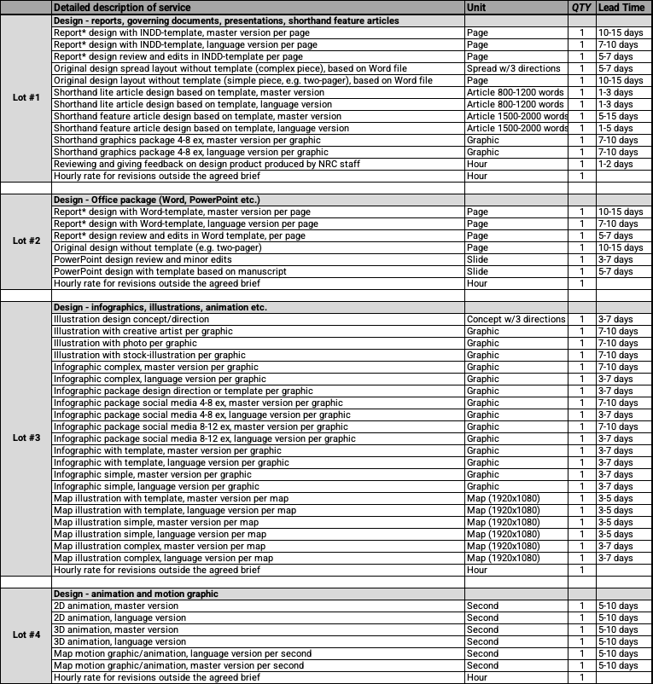
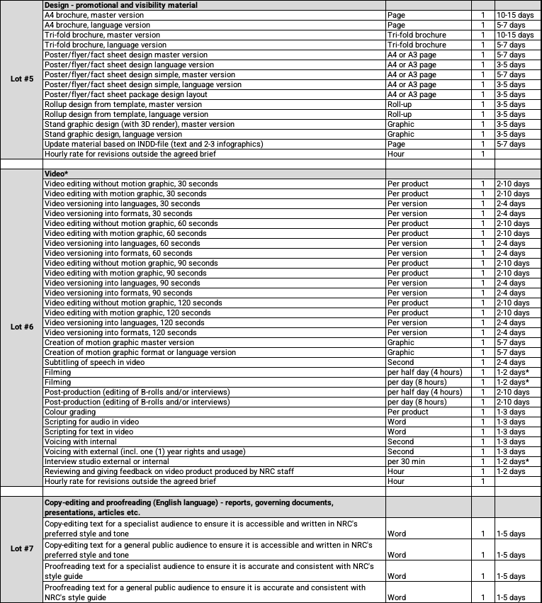

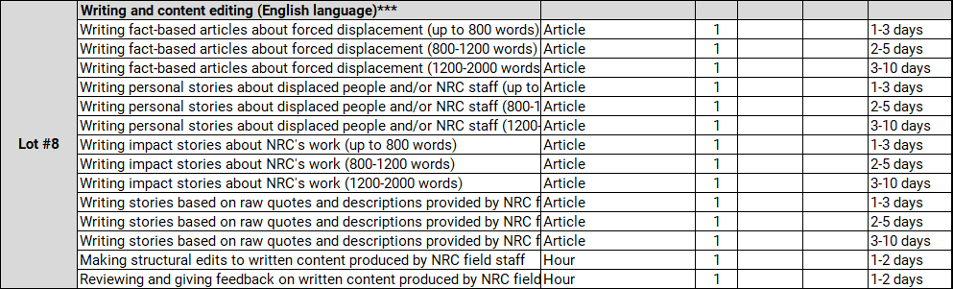
*The word ”Report" is used to refer to all long documents and can be substituted for assessment, evaluation, guideline, policy, strategy, thematic paper, or any other internal governing document.
**Video from A-Z can take between 2-10 days depending on deliverables. Delivery time must be agreed on project by project.

***It is assumed that any interviews and information-gathering can be conducted remotely, with no travel required.
****For Lots 1-6 (design, animation, video): Price includes one (1) round of proofreading and presupposes complete brief with signed-off content/material.
- Copyright and right of ownership
The right of ownership, the copyright and all other relevant rights, including all other relevant intellectual property rights, associated with the assignment shall accrue to NRC when payment has been made.

- Taxes/VAT
All quoted prices should be net and exclusive of any tax/VAT. However, please explain here any eventual VAT/taxation requirements related to international trade of services that should be considered in the country of company registration:

- Contract management proposal

As a part of the proposal, we would be looking for guidance from the bidders on how you would propose to manage orders, production process and payments, for example do you have an online system for placing orders and / or would you consider a full-time focal point?

Please answer the following questions (not exhaustive):
    - What system do you use for communication with clients?

    - How would you propose receiving purchase orders from NRC?

    - How would you propose receiving briefs and other materials from different requesters and country offices (i.e. multiple clients within NRC)?

    - How would NRC be able to monitor response, delivery time and quality of deliverables?

    - What is your internal system for quality assurance?

    - What system do you use for sending invoices?

    - What system do you use for (international) payments?

    - Add any additional information:

SECTION 5
Bidding Form

Please provide information against each requirement.
Additional rows can be inserted for all questions as necessary. If there is insufficient space to complete your answer in the space provided, please include on a separate attachment with a reference to the question.

- Bidder’s General Business Details
- General information

Company name:
Any other trading names of company:
Registered name of company (if different):
Nature of primary business/trade:
Primary contact name:
Job title:
Phone:
Email:
Registered Address:

Business licence number:
Country of registration
Registration date:
Expiry date:
Legal status of company (eg. partnership, private limited company, etc.)

- Owners/Managers
Please fill in the below table with the full names, title/position, the year of birth, and the country of birth of the company’s owner(s) and manager(s)*:

Full Name | Title / Position | Birth Year | Birth Country

* Please note this information is necessary in order to conduct the vetting procedure referred to in clause 25 of the Invitation to Bid-General Terms and Conditions. Owners and managers include but are not limited to Chief Executive Officer, Chief Operating Officer, Chair of the Board, Executive Director, Director, Manager.

- Employees
Please list the employees who would be involved with NRC in the event of contract award:

Employee name | Job title | Role on NRC project | Phone | Email
1.
2.
3.
…
Add more lines if needed.

- Company bank account details:

Beneficiary name:
Beneficiary account no.:
Beneficiary Bank:
Bank branch:
SWIFT:
IBAN:
Bank address:

- References
Please provide at least three client references whom NRC may contact, preferably at least one from the humanitarian sector:

Client/company name | Contact person | Phone | Email | Contract details (works, location, size, value, etc)
1.
2.
3.
…
Add more lines if needed.

- Equipment
The supplier provides their own equipment and software to complete the services. For lot 1-6, access to Creative Cloud and Microsoft Office is assumed; for lot 7-14, access to Microsoft Office is assumed.

- Defects Liability/Guarantee Period
NRC requires the supplier to keep original working files for up to six (6) months. Please confirm below that you are willing to commit to this.

☐ Yes
☐ No

Bid Validity
Please confirm the validity of your bid below as per Section 3, paragraph 16:

- Confirmation of Bidder’s Compliance

We, the Bidder, hereby certify that our tender is a genuine offer and intended to be competitive and we confirm we are eligible to participate in public procurement and meet the eligibility criteria specified in the Invitation to Bid. We confirm that the prices quoted are fixed and firm for the duration of the validity period and will not be subject to revision or variation.

We, the Bidder confirm the documents attached to this offer are those validated by us in the Section 2 Paragraph 6. Bidder's checklist.

We understand that NRC is not bound to accept the lowest, or indeed any bid, received.

We agree that NRC may verify the information provided in this form itself or through a third party as it may deem necessary.

We confirm that NRC may in its consideration of our offer, and subsequently, rely on the statements made herein.

Name of Signatory: | Tel N°:
Title of Signatory: | Name of Company:
Signature & stamp: | Date of Signing:
Signature & stamp: | Address:

SECTION 6
Service Provision Schedule
Service Schedule:

Please include here any detailed schedule that is different to the lead time proposed in Section 4 and in Annex 1: Service Provision and Pricing Proposal.

SECTION 7
Company Profile and Previous Experience
The Bidder is requested to:
- Submit the Company Profile.
- Complete the following Previous Experience Table listing the three (3) main contracts (per lot) in the past three (3) years related to the lots you are applying for.
- Submit sample work for each lot you will apply for.
  - For lot 1-5 (design), provide two samples per lot that represents the variation in the lot.
  - For lot 6 (video), provide two videos.
  - For lot 7 (copy-edit and proofreading), provide two samples, one for a specialist audience and one for a general public audience.
  - For lot 8 (writing), provide three samples showing a range of styles and audiences.

Please name the samples so that they easily match the table below including the number in column 1, name of project and sample number, e.g. “1 - DesignWorks_sample 1” and “1 – DesignWorks_sample 2”.

For all samples, submit a zipped folder attached to the bid or through an online link.

Previous Experience Table

# | Name of Project / Type of work | Lot # | Total value of the performed works (EUR) | Duration of the work contract | Starting date | Ending date | Contracting Authority / Contact person / phone / email
1
2
3
4
5
…
NOTE: The list shouldn’t be limited to this Form in regard to the number of work reported. A comprehensive list of the last three (3) years’ experience must be submitted adapting the Form to the necessary rows. NRC may conduct reference checks for previous contracts completed.

SECTION 8
Service Provision Description and Pricing Proposal

Please complete the attached Annex 1: Service Provision and Pricing Proposal, sign it, scan it, and submit it together with your bid. Also include an editable version in your bid.

The right of ownership, the copyright and all other relevant rights, including all other relevant intellectual property rights, associated with the assignment shall accrue to NRC when payment has been made.

Service provider should describe in detail their service provision and demonstrate how it complies with NRC requirements.

For lot 1-6 (design, animation, video): Price must include one (1) round of proof-reading and presupposes complete brief with signed-off content/material from NRC.

For lot 1-6 service providers could quote any other service suitable under these lots which could be taken into account during the evaluation of the offers. Please add your description and rate below lot 8.

SECTION 9
Ethical Standards Declaration for all Supply, Service and Works Contractors

We, the undersigned, (‘we’, ‘our’ or ‘us’) CONSIDERING THAT:
FIRST, we are bidding for, or entering into, a contract with the Norwegian Refugee Council (NRC) to supply goods, services or works to NRC (‘the Contract’).
SECOND, we understand that as a humanitarian organisation, NRC expects its suppliers and contractors to have high ethical standards.
THIRD, we understand that NRC therefore needs us to confirm that we adhere to the required ethical standards (‘the ethical standards’) by signing this declaration (‘the Declaration’).
THEREFORE, we DO HEREBY DECLARE as follows:

WORK TO THE BEST OF OUR ABILITIES

We will ensure that conduct, both professionally and privately, reflects positively on, and supports, the integrity of NRC’s mission and work.
This means that we, and to the best of our knowledge our Representatives, are not in any of the following situations:
- Made an offer, payment, consideration or benefit of any kind, which constitutes illegal or corrupt practice, directly or indirectly, as an inducement or reward in relation to the tendering, awarding or execution of the Contract. And not subject to legal proceedings related to that.
- Involved in any form of fraud, corruption, collusion, coercive practice, bribery, involvement in a criminal organisation or other illegal activity
- Have suspended activities, are insolvent, in receivership, bankrupt, or closing
- Have at any time been found guilty and sentenced by a court, whether in the country of employment or abroad, for a criminal offence in respect of children or vulnerable adults

This also means we are:
- Not engaged in terrorism or the material support of terrorism
- Do not sell or manufacture, directly or indirectly, weapons or anti-personnel mines or any components produced primarily for the operation thereof
- Are not involved in production of alcohol, tobacco, or pornography

TREAT OTHERS WITH RESPECT

We will contribute to a working environment founded on respect, fairness, honesty, courtesy, dignity and professionalism. This means that we will:
- Not discriminate against others, including for reasons of disability, ethnicity, gender, nationality, political opinion, race or religious beliefs.
- Value, celebrate and promote gender equality, diversity, inclusion and equity.
- Seek out, listen to and value different voices, experiences and opinions.
- Respect local customs and culture, including through our conduct, language and dress.
DO NOT HARM OR EXPLOIT OTHERS

We will treat people with dignity and respect. We will not sexually abuse, exploit or harass any person,
This means that we will:
- Not intimidate, bully, harass or mistreat others. This includes not using corporal punishment or any other form of physical, emotional or mental abuse, or neglect of children.
- Not have sexual activity with children. Sexual activity with anyone under the age of 18 is not allowed, even if it is legal in country of assignment or origin. Not knowing their age is not an excuse.
- Not have sexual activity with project participants or anyone receiving help from NRC. Suppliers, contractors and consultants are not allowed to take advantage of their position of power to develop sexual relationships with those receiving assistance.
- Not bribe or ask for sex or sexual favours in exchange for money, gifts, employment, services, assistance or opportunities. Sexual activity with sex workers is not allowed even if legal in the country of operation.
- Respect basic social rights and working conditions according to international standards in respect to labour such as fair wages and benefits, adequate working conditions and times etc.
- Never employ children (under the age of 18) in mentally or physically dangerous or hazardous work or work that interferes with schooling.
- Never knowingly obtain goods or services (hotels, restaurants, party venues, transport, and other service providers) from providers that employ children in mentally or physically dangerous or hazardous work or work that interferes with schooling.
- Never employ children under the age of 15 in full-time work including in household/non-workplace related work.
- Never benefit from forced or trafficked labour or other forms of labour exploitation inside and outside of work.

This means that all workers:
- Receive a contract of employment that is written in a language they understand and are free to leave after giving reasonable notice.
- Have the right to join or form trade unions of their own choosing and to bargain collectively where legally applicable.
- Are not required to lodge ‘deposits’ or identity papers or immigration documents in order to obtain employment.
- Have working hours that comply with national laws and benchmark industry standards, whichever affords greater protection.
- Receive wages and benefits paid for a standard working week that meet, at a minimum, national legal standards or industry benchmark standards, whichever is higher and always sufficient to meet basic needs.
- Whenever possible do not exceed 48 working hours per week (8 hours per day).

This also means that we will:
- Not solicit persons for the purpose of employment or offer employment by means of materially false or fraudulent pretences, representations, or promises, or charge recruitment fees.
- Not deduct from wages as a disciplinary measure.
- Provide workers with at least one day off for every 7-day period.
- Those with housed employees ensure accommodation is clean, safe and suitable for living (with toilets, access to water…).

PROTECT OUR OWN AND OTHERS’ SAFETY, HEALTH AND WELLBEING

We will actively contribute to creating and maintaining a safe and supportive working environment for everyone.
We will avoid taking unnecessary risks that could harm our own or others’ safety, health or wellbeing.
We will not work, or drive an NRC or other vehicle, while under the influence of alcohol or drugs.
We will not possess, deal or use illegal substances in any NRC workplace; at any NRC-related work or social event; or in any vehicle or accommodation that we are in due to our work for NRC.

ACT ETHICALLY

We will act in accordance with the humanitarian principles of humanity, impartiality, neutrality and independence in the work we do for NRC and will not engage in any criminal, unethical or dishonest activities, or in any behaviour that violates or undermines human rights.

We will comply with the Conflict of Interest Policy and will declare any actual or perceived conflicts of interest.
- Where any potential conflict of interest exists between our Representatives and NRC or any NRC staff member, we shall notify NRC in writing of the potential conflict using NRC’s Conflict of Interest Policy.
We will work within applicable laws and export laws and regulations, and follow NRC policies and procedures and declare that we and, to the best of our knowledge, our Representatives:
- Are registered with the relevant government authority with regard to taxation for the duration of the Contract.

- Pay taxes according to all applicable national laws and regulations for the duration of the Contract.

We will work in a way which supports NRC in reducing its environmental impact and protecting and preserving the natural environment, respect national and international environmental legislation and regulation.

This means that we will:
- Ensure that production and extraction of raw materials for production does not contribute to the destruction of the resources and income base for marginalised populations
- Take environmental measures into consideration throughout the production and distribution chain ranging from the production of raw material to the consumer sale.
  - This includes reasonable steps to minimise negative environmental impacts (e.g. emissions, water usage, waste) and to use - where possible - sustainable resources.
  - Local, regional and global environmental aspects shall be considered.
- Ensure the local environment at the production site will not be exploited or degraded by pollution and waste.
- Carefully manage hazardous chemicals and other substances in accordance with documented safety procedures.

ACT WITH HONESTY AND INTEGRITY

We will not engage in any form of bribery or corruption and will appropriately manage, safeguard and accurately account for all NRC funds, assets and resources that we are responsible for.
We will take all reasonable steps to prevent or reduce the risk of aid diversion, including NRC funds or assets being intentionally or negligently diverted to sanctioned individuals or entities.
We will not abuse or take advantage of any privilege, power, trust or authority that we have as a Supplier, Contractor, or Consultant.
We will not accept honours, gifts, money or hospitality offered to us as a result of our work for or with NRC, except for small tokens of appreciation that do not influence or appear to influence our professional decisions.
We will ensure that NRC assistance is never provided in exchange for service, favour or benefit for ourselves or others.

COMMUNICATE RESPONSIBLY

We will communicate professionally, respectfully and in accordance with the humanitarian principles in our interactions online and offline.
- We will not engage in communications online or offline that could put the people NRC works with or NRC representatives at risk, or that could harm NRC’s reputation, credibility or public image.
- We understand that we have a right to freedom of expression. However, if we are engaging in political or controversial discussions online or offline, we will be clear that we are expressing personal views and not those of NRC.
- We will not misuse NRC’s name or logo or make unauthorised statements on behalf of NRC.

PROTECT NRC ASSETS AND INFORMATION

We will treat information confidentially and in accordance with the Personal Data and Privacy Policy and applicable laws.
- We will safeguard and make responsible use of information and resources that we have access to as a Supplier, Consultant or Contractor at NRC.
- We will take care of NRC assets and protect them from damage, misuse, theft or other harm.

BE ACCOUNTABLE

We will report any concerns of serious misconduct, in accordance with the Speak Up Policy.
- We will report concerns via inbox@nrc.caseiq.app or this online form, honestly and in good faith.
- We understand that we are protected from retaliation when doing so. We will not retaliate against anyone who raises a concern.
- We will maintain the confidentiality of others who are involved in raising a concern.
- We will fully cooperate with any investigation, audit or fact-finding process that we are involved in.
- We will not conceal or destroy evidence, and we will always tell the truth.

Signed on our behalf as follows:
Signature
Name
Position
Date
Place

