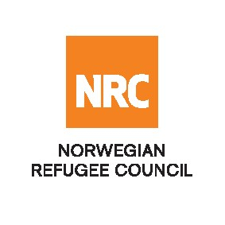
TENDER NOTICE

The Norwegian Refugee Council (NRC) is an independent, humanitarian, non-profit, non-governmental organisation which provides assistance, protection and durable solutions to refugees and internally displaced persons worldwide.
NRC has been working in Burkina Faso since 2019 on Shelter, WASH, Education, ICLA, LFS, Cash transfer.

The Norwegian Refugee Council (NRC) invites qualified suppliers from Burkina Faso and others to provide Seeds and Farming tools.

Project: All Projects and donors

Lot N° | Description | Tender number
MANY | FOOD ITEMS, FARM, RUMINANTS, ANIMAL VACCINES FOR LIVELIHOODS ACTIVITIES IN NORTH, CENTRAL NORTH AND THE SAHEL REGION (BURKINA FASO). | ITT – BF – 21 –002

Tender request
To receive the tender package, interested suppliers may obtain tender documents from NRC’s in Ouaga 2000, 3ème avenue au nord, Avenue Pascal ZAGRE Lot 29 Section F Parcelle 05 ET à Kaya situé derrière le commissariat de Kaya, Porte no 102 Burkina Faso or requested by email to bf.logistics@nrc.no

Submission
All bidders are required to submit their bids in a sealed envelope with the bid reference number clearly indicated, ITT-BF-20-002 Submission of Bids.

For any tender queries:: bf.logistics@nrc.no

Any questions related to the location and direction of the NRC office should be directed by telephone: +226 77 10 38 13 / 07 77 10 92
NRC will not be responsible for any costs or expenses incurred by the Bidders in connection with the preparation and submission of their bids to NRC.

Deadline: All bids must be submitted no later than 12th of April, 2021 at 13: 00 pm (local time) at the NRC address mentioned above in a sealed envelope.
Late bids will be automatically rejected.

