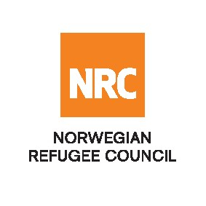
CALL FOR CONSULTANCY SERVICES

The Norwegian Refugee Council (NRC) invites qualified firms/ Consultants to tender for the following consultancy service:

SCOPE OF SERVICE
The Contracts eligible for bidding are

Service Description | Reference contract :
Consultancy_ Monitoring and Evaluation for Burkina Faso & Niger | RFQ/ SN/19 SEP / 2022/002

Tender documents
Download the full TOR and RFQ with detailed instructions HERE

For additional information, please send your inquiries to: sn.procurement@nrc.no before the closing date

Submission process
All interested and eligible firms/ consultants are requested to submit their bids to sn.procurement@nrc.no

Deadline: All bids must be submitted no later than 30 of September, 2022 at 11: 00 Am (Dakar time) by email to sn.procurement@nrc.no
Late bids will be automatically rejected.

