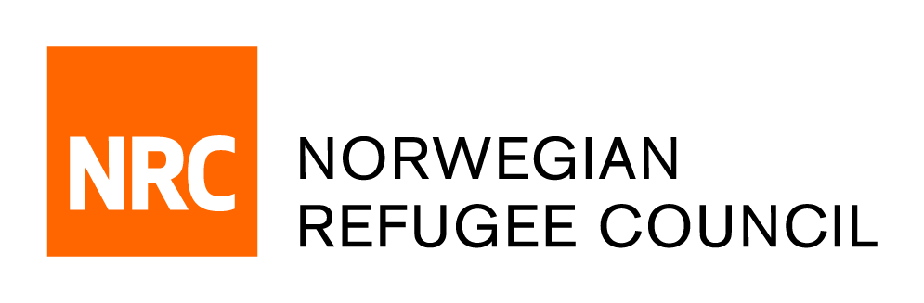

Tender Notice
i2SelfLearn
ITB.SY.2018.7893

NRC Syria Response in Amman, Jordan is soliciting bids from reputable suppliers for a service to use mobile devices to deliver Self-Learning educational materials and remote support to learners.

Deadline for submissions: The deadline for submission of bids is 10:00 hrs GMT/ (12:00 pm Jordan timing)
on 01, April 2018 companies who do not submit their bid by this deadline will not be considered.

The complete tender dossier in English language can be obtained by e-mail, free of charge, up until the day before the closing date 01 April 2018. The tender dossier can be requested by emailing sy.procurement@nrc.no quoting reference number ITB.SY.2018.7893 and stating the name of the company requesting the documents.

